Data Graph
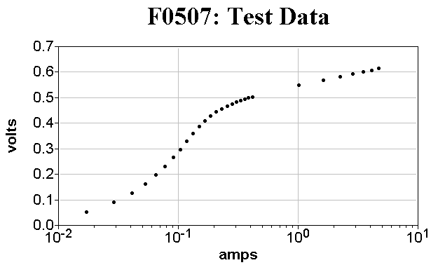

Data
Pt# | amps | volts | SigmaY
1 | 1.710E-0002 | 5.330E-0002 | 5.300E-0003
2 | 2.890E-0002 | 8.960E-0002 | 9.000E-0003
3 | 4.090E-0002 | 1.260E-0001 | 1.300E-0002
4 | 5.290E-0002 | 1.610E-0001 | 1.600E-0002
5 | 6.520E-0002 | 1.970E-0001 | 2.000E-0002
6 | 7.790E-0002 | 2.310E-0001 | 2.300E-0002
7 | 9.050E-0002 | 2.650E-0001 | 2.600E-0002
8 | 1.040E-0001 | 2.970E-0001 | 3.000E-0002
9 | 1.180E-0001 | 3.290E-0001 | 3.300E-0002
10 | 1.320E-0001 | 3.590E-0001 | 3.600E-0002
11 | 1.490E-0001 | 3.860E-0001 | 3.900E-0002
12 | 1.670E-0001 | 4.090E-0001 | 4.100E-0002
13 | 1.870E-0001 | 4.290E-0001 | 4.300E-0002
14 | 2.080E-0001 | 4.450E-0001 | 4.400E-0002
15 | 2.320E-0001 | 4.570E-0001 | 4.600E-0002
16 | 2.560E-0001 | 4.680E-0001 | 4.700E-0002
17 | 2.810E-0001 | 4.760E-0001 | 4.800E-0002
18 | 3.070E-0001 | 4.830E-0001 | 4.800E-0002
19 | 3.330E-0001 | 4.890E-0001 | 4.900E-0002
20 | 3.600E-0001 | 4.940E-0001 | 4.900E-0002
21 | 3.870E-0001 | 4.990E-0001 | 5.000E-0002
22 | 4.150E-0001 | 5.030E-0001 | 5.000E-0002
23 | 4.160E-0001 | 5.030E-0001 | 5.000E-0002
24 | 1.020E+0000 | 5.480E-0001 | 5.500E-0002
25 | 1.630E+0000 | 5.680E-0001 | 5.700E-0002
26 | 2.250E+0000 | 5.810E-0001 | 5.800E-0002
27 | 2.870E+0000 | 5.920E-0001 | 5.900E-0002
28 | 3.480E+0000 | 6.010E-0001 | 6.000E-0002
29 | 4.100E+0000 | 6.080E-0001 | 6.100E-0002
30 | 4.700E+0000 | 6.150E-0001 | 6.100E-0002

Fit Graph
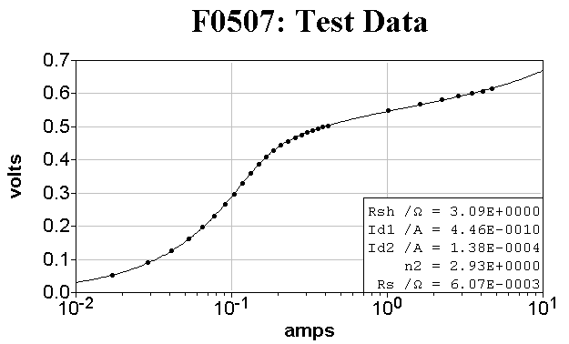

Fit
File: | c:\users\public\fitall10\data\f0507tst.dta
Title: | F0507: Test Data
Sub-Title:
Function: | 0507..Dark I-V: Model 4A: Full I-Range
Analysis Method: | Nonlinear Least Squares (nls)
Analysis Range: | 1 to 30 of 30
Weighted as: | 1
Variance: | 1.23599271676699E-6
Std. Dev. of Fit: | 0.00111175209321457
Iterations: | 22

Parameter | Name | Value | Std. Dev. | RSD /%
1 | Rsh /Ω | 3.086E+0000 | 1.814E-0002 | 0.59
2 | Id1 /A | 4.463E-0010 | 2.301E-0011 | 5.16
3 | Id2 /A | 1.376E-0004 | 3.719E-0005 | 27.03
4 | n2 | 2.929E+0000 | 1.343E-0001 | 4.58
5 | Rs /Ω | 6.070E-0003 | 3.415E-0004 | 5.63
Constant
1 | q/k /C°K/J | 1.164E+0004
2 | t /°C | 2.500E+0001
3 | Ns | 1.000E+0000
4 | Np | 1.000E+0000
5 | Max V /V | 9.225E-0001

Residuals Graph
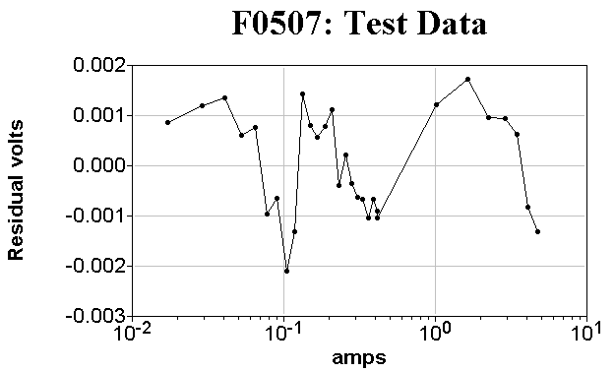

Residuals
File: | c:\users\public\fitall10\data\f0507tst.dta
Title: | F0507: Test Data
Sub-Title:
Function: | 0507..Dark I-V: Model 4A: Full I-Range
Analysis Method: | Nonlinear Least Squares (nls)
Analysis Range: | 1 to 30 of 30
Weighted as: | 1
Variance: | 1.23599271676699E-6
Std. Dev. of Fit: | 0.00111175209321457
Iterations: | 22

Pt# | amps | volts | SigmaY | Ycalc | Y-Ycalc
1 | 1.710E-0002 | 5.330E-0002 | 5.300E-0003 | 5.244E-0002 | 8.574E-0004
2 | 2.890E-0002 | 8.960E-0002 | 9.000E-0003 | 8.840E-0002 | 1.197E-0003
3 | 4.090E-0002 | 1.260E-0001 | 1.300E-0002 | 1.247E-0001 | 1.348E-0003
4 | 5.290E-0002 | 1.610E-0001 | 1.600E-0002 | 1.604E-0001 | 6.042E-0004
5 | 6.520E-0002 | 1.970E-0001 | 2.000E-0002 | 1.962E-0001 | 7.690E-0004
6 | 7.790E-0002 | 2.310E-0001 | 2.300E-0002 | 2.320E-0001 | -9.689E-0004
7 | 9.050E-0002 | 2.650E-0001 | 2.600E-0002 | 2.656E-0001 | -6.383E-0004
8 | 1.040E-0001 | 2.970E-0001 | 3.000E-0002 | 2.991E-0001 | -2.100E-0003
9 | 1.180E-0001 | 3.290E-0001 | 3.300E-0002 | 3.303E-0001 | -1.317E-0003
10 | 1.320E-0001 | 3.590E-0001 | 3.600E-0002 | 3.576E-0001 | 1.433E-0003
11 | 1.490E-0001 | 3.860E-0001 | 3.900E-0002 | 3.852E-0001 | 7.959E-0004
12 | 1.670E-0001 | 4.090E-0001 | 4.100E-0002 | 4.084E-0001 | 5.705E-0004
13 | 1.870E-0001 | 4.290E-0001 | 4.300E-0002 | 4.282E-0001 | 7.888E-0004
14 | 2.080E-0001 | 4.450E-0001 | 4.400E-0002 | 4.439E-0001 | 1.113E-0003
15 | 2.320E-0001 | 4.570E-0001 | 4.600E-0002 | 4.574E-0001 | -4.011E-0004
16 | 2.560E-0001 | 4.680E-0001 | 4.700E-0002 | 4.678E-0001 | 2.213E-0004
17 | 2.810E-0001 | 4.760E-0001 | 4.800E-0002 | 4.764E-0001 | -3.580E-0004
18 | 3.070E-0001 | 4.830E-0001 | 4.800E-0002 | 4.836E-0001 | -6.181E-0004
19 | 3.330E-0001 | 4.890E-0001 | 4.900E-0002 | 4.897E-0001 | -6.744E-0004
20 | 3.600E-0001 | 4.940E-0001 | 4.900E-0002 | 4.950E-0001 | -1.031E-0003
21 | 3.870E-0001 | 4.990E-0001 | 5.000E-0002 | 4.997E-0001 | -6.715E-0004
22 | 4.150E-0001 | 5.030E-0001 | 5.000E-0002 | 5.039E-0001 | -8.997E-0004
23 | 4.160E-0001 | 5.030E-0001 | 5.000E-0002 | 5.040E-0001 | -1.041E-0003
24 | 1.020E+0000 | 5.480E-0001 | 5.500E-0002 | 5.468E-0001 | 1.207E-0003
25 | 1.630E+0000 | 5.680E-0001 | 5.700E-0002 | 5.663E-0001 | 1.728E-0003
26 | 2.250E+0000 | 5.810E-0001 | 5.800E-0002 | 5.800E-0001 | 9.516E-0004
27 | 2.870E+0000 | 5.920E-0001 | 5.900E-0002 | 5.911E-0001 | 9.334E-0004
28 | 3.480E+0000 | 6.010E-0001 | 6.000E-0002 | 6.004E-0001 | 6.290E-0004
29 | 4.100E+0000 | 6.080E-0001 | 6.100E-0002 | 6.088E-0001 | -8.185E-0004
30 | 4.700E+0000 | 6.150E-0001 | 6.100E-0002 | 6.163E-0001 | -1.313E-0003

Residuals Distribution Graph
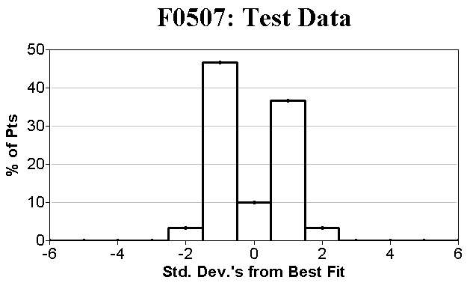

Residuals Distribution
File: | c:\users\public\fitall10\data\f0507tst.dta
Title: | F0507: Test Data
Sub-Title:
Function: | 0507..Dark I-V: Model 4A: Full I-Range
Analysis Method: | Nonlinear Least Squares (nls)
Analysis Range: | 1 to 30 of 30
Weighted as: | 1
Variance: | 1.23599271676699E-6
Std. Dev. of Fit: | 0.00111175209321457
Iterations: | 22

Std. Dev.'s from Best Fit | # of Pts | % of Pts
-6.5 to -5.5 | 0 | 0.00
-5.5 to -4.5 | 0 | 0.00
-4.5 to -3.5 | 0 | 0.00
-3.5 to -2.5 | 0 | 0.00
-2.5 to -1.5 | 1 | 3.33
-1.5 to -0.5 | 14 | 46.67
-0.5 to 0.5 | 3 | 10.00
0.5 to 1.5 | 11 | 36.67
1.5 to 2.5 | 1 | 3.33
2.5 to 3.5 | 0 | 0.00
3.5 to 4.5 | 0 | 0.00
4.5 to 5.5 | 0 | 0.00

Sensitivities Graph
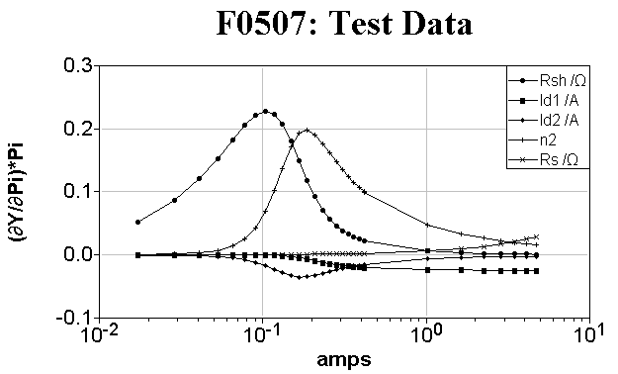

Sensitivities
File: | c:\users\public\fitall10\data\f0507tst.dta
Title: | F0507: Test Data
Sub-Title:
Function: | 0507..Dark I-V: Model 4A: Full I-Range
Analysis Method: | Nonlinear Least Squares (nls)
Analysis Range: | 1 to 30 of 30
Weighted as: | 1
Variance: | 1.23599271676699E-6
Std. Dev. of Fit: | 0.00111175209321457
Iterations: | 22

Pt# | amps | volts | SigmaY | (∂Y/∂P1)*P1 | (∂Y/∂P2)*P2 | (∂Y/∂P3)*P3 | (∂Y/∂P4)*P4 | (∂Y/∂P5)*P5
1 | 1.710E-0002 | 5.330E-0002 | 5.300E-0003 | 5.175E-0002 | -9.154E-0009 | -4.238E-0004 | 5.887E-0004 | 1.038E-0004
2 | 2.890E-0002 | 8.960E-0002 | 9.000E-0003 | 8.664E-0002 | -4.107E-0008 | -9.350E-0004 | 1.591E-0003 | 1.754E-0004
3 | 4.090E-0002 | 1.260E-0001 | 1.300E-0002 | 1.208E-0001 | -1.710E-0007 | -1.754E-0003 | 3.593E-0003 | 2.483E-0004
4 | 5.290E-0002 | 1.610E-0001 | 1.600E-0002 | 1.528E-0001 | -6.807E-0007 | -3.020E-0003 | 7.310E-0003 | 3.211E-0004
5 | 6.520E-0002 | 1.970E-0001 | 2.000E-0002 | 1.818E-0001 | -2.680E-0006 | -4.973E-0003 | 1.402E-0002 | 3.958E-0004
6 | 7.790E-0002 | 2.310E-0001 | 2.300E-0002 | 2.059E-0001 | -1.034E-0005 | -7.894E-0003 | 2.554E-0002 | 4.729E-0004
7 | 9.050E-0002 | 2.650E-0001 | 2.600E-0002 | 2.217E-0001 | -3.611E-0005 | -1.182E-0002 | 4.304E-0002 | 5.493E-0004
8 | 1.040E-0001 | 2.970E-0001 | 3.000E-0002 | 2.280E-0001 | -1.215E-0004 | -1.703E-0002 | 6.908E-0002 | 6.313E-0004
9 | 1.180E-0001 | 3.290E-0001 | 3.300E-0002 | 2.227E-0001 | -3.624E-0004 | -2.297E-0002 | 1.022E-0001 | 7.163E-0004
10 | 1.320E-0001 | 3.590E-0001 | 3.600E-0002 | 2.074E-0001 | -9.010E-0004 | -2.850E-0002 | 1.368E-0001 | 8.012E-0004
11 | 1.490E-0001 | 3.860E-0001 | 3.900E-0002 | 1.805E-0001 | -2.133E-0003 | -3.332E-0002 | 1.718E-0001 | 9.044E-0004
12 | 1.670E-0001 | 4.090E-0001 | 4.100E-0002 | 1.491E-0001 | -4.099E-0003 | -3.539E-0002 | 1.931E-0001 | 1.014E-0003
13 | 1.870E-0001 | 4.290E-0001 | 4.300E-0002 | 1.178E-0001 | -6.657E-0003 | -3.470E-0002 | 1.983E-0001 | 1.135E-0003
14 | 2.080E-0001 | 4.450E-0001 | 4.400E-0002 | 9.218E-0002 | -9.227E-0003 | -3.226E-0002 | 1.909E-0001 | 1.263E-0003
15 | 2.320E-0001 | 4.570E-0001 | 4.600E-0002 | 7.133E-0002 | -1.168E-0002 | -2.898E-0002 | 1.766E-0001 | 1.408E-0003
16 | 2.560E-0001 | 4.680E-0001 | 4.700E-0002 | 5.695E-0002 | -1.360E-0002 | -2.594E-0002 | 1.616E-0001 | 1.554E-0003
17 | 2.810E-0001 | 4.760E-0001 | 4.800E-0002 | 4.644E-0002 | -1.514E-0002 | -2.326E-0002 | 1.475E-0001 | 1.706E-0003
18 | 3.070E-0001 | 4.830E-0001 | 4.800E-0002 | 3.864E-0002 | -1.638E-0002 | -2.096E-0002 | 1.349E-0001 | 1.863E-0003
19 | 3.330E-0001 | 4.890E-0001 | 4.900E-0002 | 3.291E-0002 | -1.735E-0002 | -1.908E-0002 | 1.243E-0001 | 2.021E-0003
20 | 3.600E-0001 | 4.940E-0001 | 4.900E-0002 | 2.841E-0002 | -1.816E-0002 | -1.747E-0002 | 1.150E-0001 | 2.185E-0003
21 | 3.870E-0001 | 4.990E-0001 | 5.000E-0002 | 2.493E-0002 | -1.881E-0002 | -1.613E-0002 | 1.071E-0001 | 2.349E-0003
22 | 4.150E-0001 | 5.030E-0001 | 5.000E-0002 | 2.208E-0002 | -1.936E-0002 | -1.496E-0002 | 1.002E-0001 | 2.519E-0003
23 | 4.160E-0001 | 5.030E-0001 | 5.000E-0002 | 2.199E-0002 | -1.938E-0002 | -1.492E-0002 | 9.993E-0002 | 2.525E-0003
24 | 1.020E+0000 | 5.480E-0001 | 5.500E-0002 | 6.138E-0003 | -2.309E-0002 | -6.510E-0003 | 4.696E-0002 | 6.191E-0003
25 | 1.630E+0000 | 5.680E-0001 | 5.700E-0002 | 3.532E-0003 | -2.391E-0002 | -4.493E-0003 | 3.335E-0002 | 9.894E-0003
26 | 2.250E+0000 | 5.810E-0001 | 5.800E-0002 | 2.471E-0003 | -2.429E-0002 | -3.528E-0003 | 2.666E-0002 | 1.366E-0002
27 | 2.870E+0000 | 5.920E-0001 | 5.900E-0002 | 1.902E-0003 | -2.451E-0002 | -2.955E-0003 | 2.261E-0002 | 1.742E-0002
28 | 3.480E+0000 | 6.010E-0001 | 6.000E-0002 | 1.553E-0003 | -2.466E-0002 | -2.574E-0003 | 1.989E-0002 | 2.112E-0002
29 | 4.100E+0000 | 6.080E-0001 | 6.100E-0002 | 1.309E-0003 | -2.477E-0002 | -2.292E-0003 | 1.785E-0002 | 2.489E-0002
30 | 4.700E+0000 | 6.150E-0001 | 6.100E-0002 | 1.137E-0003 | -2.485E-0002 | -2.082E-0003 | 1.633E-0002 | 2.853E-0002

Standard Stats
File: | c:\users\public\fitall10\data\f0507tst.dta
Title: | F0507: Test Data
Sub-Title:
Analysis Range: | 1 to 30 of 30

Col. Name | Minimum | Mean | Median | Maximum | Std. Dev. | Ave. Dev. | Skew | Kurtosis
amps | 1.710E-0002 | 8.158E-0001 | 2.440E-0001 | 4.700E+0000 | 1.303E+0000 | 9.559E-0001 | 1.789E+0000 | 4.865E+0000
volts | 5.330E-0002 | 4.087E-0001 | 4.625E-0001 | 6.150E-0001 | 1.633E-0001 | 1.335E-0001 | -6.809E-0001 | 2.267E+0000
SigmaY | 5.300E-0003 | 4.088E-0002 | 4.650E-0002 | 6.100E-0002 | 1.627E-0002 | 1.329E-0002 | -6.863E-0001 | 2.272E+0000

Pearson's R (Lin. Corr. Coeff.)
File: | c:\users\public\fitall10\data\f0507tst.dta
Title: | F0507: Test Data
Sub-Title:
Analysis Range: | 1 to 30 of 30

Column1 | Column2 | R | R^2 | ProbR | Z
amps | volts | 6.336E-0001 | 4.014E-0001 | 1.710E-0004 | 7.474E-0001
amps | SigmaY | 6.317E-0001 | 3.990E-0001 | 1.812E-0004 | 7.442E-0001
volts | SigmaY | 9.999E-0001 | 9.997E-0001 | 2.675E-0051 | 4.784E+0000

Kendall's Tau
File: | c:\users\public\fitall10\data\f0507tst.dta
Title: | F0507: Test Data
Sub-Title:
Analysis Range: | 1 to 30 of 30

Column1 | Column2 | Tau | ZTau | ProbTau
amps | volts | 9.988E-0001 | 7.752E+0000 | 9.051E-0015
amps | SigmaY | 9.931E-0001 | 7.707E+0000 | 1.287E-0014
volts | SigmaY | 9.942E-0001 | 7.716E+0000 | 1.200E-0014

Spearman's Rank Order
File: | c:\users\public\fitall10\data\f0507tst.dta
Title: | F0507: Test Data
Sub-Title:
Analysis Range: | 1 to 30 of 30

Column1 | Column2 | Rs | ProbRs
amps | volts | 9.994E-0001 | 6.633E-0043
amps | SigmaY | 9.961E-0001 | 4.492E-0031
volts | SigmaY | 9.958E-0001 | 1.424E-0030

Sum Squared Difference Of Rank
File: | c:\users\public\fitall10\data\f0507tst.dta
Title: | F0507: Test Data
Sub-Title:
Analysis Range: | 1 to 30 of 30

Column1 | Column2 | D | ZD | ProbD
amps | volts | 5.000E-0001 | -5.385E+0000 | 7.262E-0008
amps | SigmaY | 3.500E+0000 | -5.381E+0000 | 7.409E-0008
volts | SigmaY | 3.000E+0000 | -5.382E+0000 | 7.384E-0008

Info
Data
Directory: | c:\users\public\fitall10\data\
File: | f0507tst.dta
Saved?: | True
Title: | F0507: Test Data
Sub-Title:
Points: | 30
Max. Points: | 1024
Columns: | 3
Max. Columns: | 32
Function:
Name: | 0507..Dark I-V: Model 4A: Full I-Range
Parameters: | 5
Constants: | 5
Variables: | 1
FitAll | Research Edition
Version: | 10.0.0.564 (32 Bit)
SN: | FA010R-
Libraries: | FFL: User Requested Ftns 10.0.0.15 (32 Bit)
 | FFL: Basic 10.0.0.57 (32 Bit)
 | FFL: Scripted Ftns 10.0.0.44 (32 Bit)
 | FFL: Binding + Growth Curves 10.0.0.18 (32 Bit)
 | FFL: Peaks 10.0.0.14 (32 Bit)
 | FFL: Chemistry 10.0.0.13 (32 Bit)
 | FFL: Solar Cell 10.0.0.14 (32 Bit)
 | FFL: Examples 10.0.0.20 (32 Bit)
MS Windows version: | 10.0.0.19041 (64 Bit)
MS Word Version: | 12.0.6787.5000
LibreOffice Version: | 6.4.7.2

