Data Graph
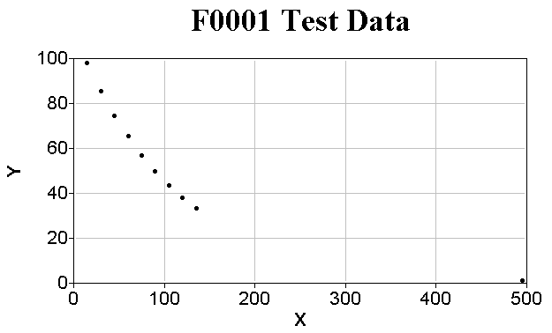

Data
Pt# | X | Y | SigmaY
1 | 1.500E+0001 | 9.790E+0001 | 1.000E+0000
2 | 3.000E+0001 | 8.550E+0001 | 1.000E+0000
3 | 4.500E+0001 | 7.470E+0001 | 1.000E+0000
4 | 6.000E+0001 | 6.530E+0001 | 1.000E+0000
5 | 7.500E+0001 | 5.700E+0001 | 1.000E+0000
6 | 9.000E+0001 | 4.990E+0001 | 1.000E+0000
7 | 1.050E+0002 | 4.360E+0001 | 1.000E+0000
8 | 1.200E+0002 | 3.810E+0001 | 1.000E+0000
9 | 1.350E+0002 | 3.330E+0001 | 1.000E+0000
10 | 4.950E+0002 | 1.000E+0000 | 1.000E+0000

Fit Graph
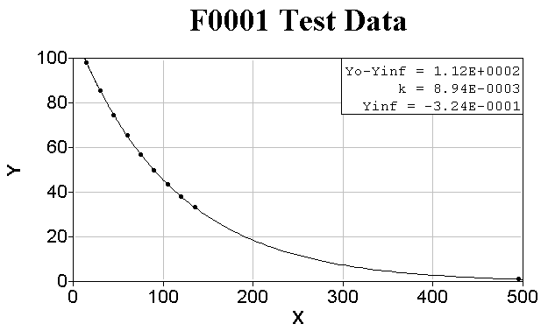

Fit
File: | c:\users\public\fitall10\data\f0001tst.dta
Title: | F0001 Test Data
Sub-Title:
Function: | 0001..1st order exponential + bkgrnd: Y=P1*exp(-P2*K1*X) + Σ{A[i]*X^(i)}
Analysis Method: | Nonlinear Least Squares (nls)
Analysis Range: | 1 to 10 of 10
Weighted as: | 1
Variance: | 0.0026489458897368
Std. Dev. of Fit: | 0.0514679112626188
Iterations: | 4

Parameter | Name | Value | Std. Dev. | RSD /%
1 | Yo-Yinf | 1.122E+0002 | 6.866E-0002 | 0.06
2 | k | 8.940E-0003 | 1.201E-0005 | 0.13
3 | Yinf | -3.243E-0001 | 5.707E-0002 | 17.60
Constant
1 | K1 | 1.000E+0000

Residuals Graph
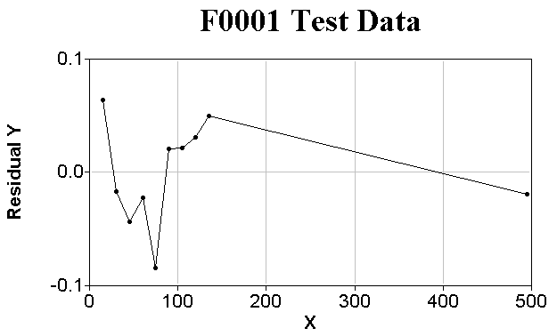

Residuals
File: | c:\users\public\fitall10\data\f0001tst.dta
Title: | F0001 Test Data
Sub-Title:
Function: | 0001..1st order exponential + bkgrnd: Y=P1*exp(-P2*K1*X) + Σ{A[i]*X^(i)}
Analysis Method: | Nonlinear Least Squares (nls)
Analysis Range: | 1 to 10 of 10
Weighted as: | 1
Variance: | 0.0026489458897368
Std. Dev. of Fit: | 0.0514679112626188
Iterations: | 4

Pt# | X | Y | SigmaY | Ycalc | Y-Ycalc
1 | 1.500E+0001 | 9.790E+0001 | 1.000E+0000 | 9.784E+0001 | 6.361E-0002
2 | 3.000E+0001 | 8.550E+0001 | 1.000E+0000 | 8.552E+0001 | -1.710E-0002
3 | 4.500E+0001 | 7.470E+0001 | 1.000E+0000 | 7.474E+0001 | -4.390E-0002
4 | 6.000E+0001 | 6.530E+0001 | 1.000E+0000 | 6.532E+0001 | -2.274E-0002
5 | 7.500E+0001 | 5.700E+0001 | 1.000E+0000 | 5.708E+0001 | -8.396E-0002
6 | 9.000E+0001 | 4.990E+0001 | 1.000E+0000 | 4.988E+0001 | 2.085E-0002
7 | 1.050E+0002 | 4.360E+0001 | 1.000E+0000 | 4.358E+0001 | 2.145E-0002
8 | 1.200E+0002 | 3.810E+0001 | 1.000E+0000 | 3.807E+0001 | 3.131E-0002
9 | 1.350E+0002 | 3.330E+0001 | 1.000E+0000 | 3.325E+0001 | 4.968E-0002
10 | 4.950E+0002 | 1.000E+0000 | 1.000E+0000 | 1.019E+0000 | -1.919E-0002

Residuals Distribution Graph
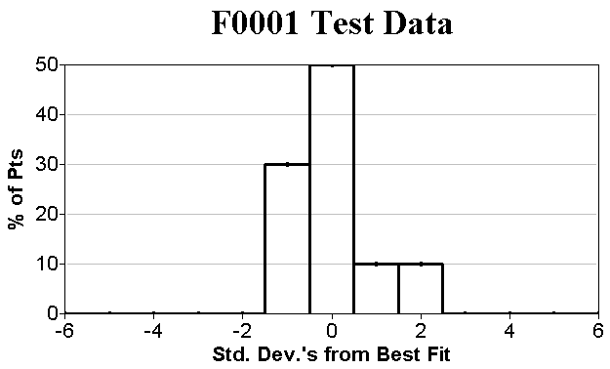

Residuals Distribution
File: | c:\users\public\fitall10\data\f0001tst.dta
Title: | F0001 Test Data
Sub-Title:
Function: | 0001..1st order exponential + bkgrnd: Y=P1*exp(-P2*K1*X) + Σ{A[i]*X^(i)}
Analysis Method: | Nonlinear Least Squares (nls)
Analysis Range: | 1 to 10 of 10
Weighted as: | 1
Variance: | 0.0026489458897368
Std. Dev. of Fit: | 0.0514679112626188
Iterations: | 4

Std. Dev.'s from Best Fit | # of Pts | % of Pts
-6.5 to -5.5 | 0 | 0.00
-5.5 to -4.5 | 0 | 0.00
-4.5 to -3.5 | 0 | 0.00
-3.5 to -2.5 | 0 | 0.00
-2.5 to -1.5 | 0 | 0.00
-1.5 to -0.5 | 3 | 30.00
-0.5 to 0.5 | 5 | 50.00
0.5 to 1.5 | 1 | 10.00
1.5 to 2.5 | 1 | 10.00
2.5 to 3.5 | 0 | 0.00
3.5 to 4.5 | 0 | 0.00
4.5 to 5.5 | 0 | 0.00

Sensitivities Graph
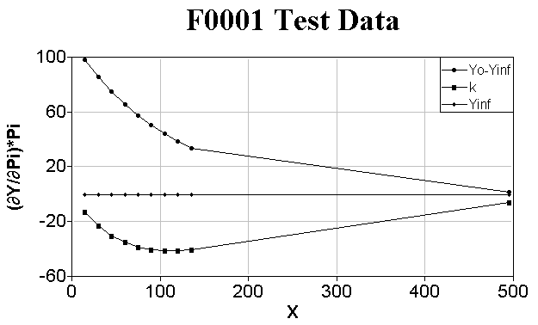

Sensitivities
File: | c:\users\public\fitall10\data\f0001tst.dta
Title: | F0001 Test Data
Sub-Title:
Function: | 0001..1st order exponential + bkgrnd: Y=P1*exp(-P2*K1*X) + Σ{A[i]*X^(i)}
Analysis Method: | Nonlinear Least Squares (nls)
Analysis Range: | 1 to 10 of 10
Weighted as: | 1
Variance: | 0.0026489458897368
Std. Dev. of Fit: | 0.0514679112626188
Iterations: | 4

Pt# | X | Y | SigmaY | (∂Y/∂P1)*P1 | (∂Y/∂P2)*P2 | (∂Y/∂P3)*P3
1 | 1.500E+0001 | 9.790E+0001 | 1.000E+0000 | 9.816E+0001 | -1.316E+0001 | -3.243E-0001
2 | 3.000E+0001 | 8.550E+0001 | 1.000E+0000 | 8.584E+0001 | -2.302E+0001 | -3.243E-0001
3 | 4.500E+0001 | 7.470E+0001 | 1.000E+0000 | 7.507E+0001 | -3.020E+0001 | -3.243E-0001
4 | 6.000E+0001 | 6.530E+0001 | 1.000E+0000 | 6.565E+0001 | -3.521E+0001 | -3.243E-0001
5 | 7.500E+0001 | 5.700E+0001 | 1.000E+0000 | 5.741E+0001 | -3.849E+0001 | -3.243E-0001
6 | 9.000E+0001 | 4.990E+0001 | 1.000E+0000 | 5.020E+0001 | -4.040E+0001 | -3.243E-0001
7 | 1.050E+0002 | 4.360E+0001 | 1.000E+0000 | 4.390E+0001 | -4.121E+0001 | -3.243E-0001
8 | 1.200E+0002 | 3.810E+0001 | 1.000E+0000 | 3.839E+0001 | -4.119E+0001 | -3.243E-0001
9 | 1.350E+0002 | 3.330E+0001 | 1.000E+0000 | 3.357E+0001 | -4.052E+0001 | -3.243E-0001
10 | 4.950E+0002 | 1.000E+0000 | 1.000E+0000 | 1.343E+0000 | -5.945E+0000 | -3.243E-0001

Standard Stats
File: | c:\users\public\fitall10\data\f0001tst.dta
Title: | F0001 Test Data
Sub-Title:
Analysis Range: | 1 to 10 of 10

Col. Name | Minimum | Mean | Median | Maximum | Std. Dev. | Ave. Dev. | Skew | Kurtosis
X | 1.500E+0001 | 1.170E+0002 | 8.250E+0001 | 4.950E+0002 | 1.383E+0002 | 7.980E+0001 | 1.950E+0000 | 5.629E+0000
Y | 1.000E+0000 | 5.463E+0001 | 5.345E+0001 | 9.790E+0001 | 2.808E+0001 | 2.145E+0001 | -2.266E-0001 | 2.117E+0000
SigmaY | 1.000E+0000 | 1.000E+0000 | 1.000E+0000 | 1.000E+0000 | 0.000E+0000 | 0.000E+0000 | 0.000E+0000 | 0.000E+0000

Pearson's R (Lin. Corr. Coeff.)
File: | c:\users\public\fitall10\data\f0001tst.dta
Title: | F0001 Test Data
Sub-Title:
Analysis Range: | 1 to 10 of 10

Column1 | Column2 | R | R^2 | ProbR | Z
X | Y | -8.494E-0001 | 7.215E-0001 | 1.868E-0003 | -1.254E+0000
X | SigmaY | 0.000E+0000 | 0.000E+0000 | 1.000E+0000 | 0.000E+0000
Y | SigmaY | 0.000E+0000 | 0.000E+0000 | 1.000E+0000 | 0.000E+0000

Kendall's Tau
File: | c:\users\public\fitall10\data\f0001tst.dta
Title: | F0001 Test Data
Sub-Title:
Analysis Range: | 1 to 10 of 10

Column1 | Column2 | Tau | ZTau | ProbTau
X | Y | -1.000E+0000 | -4.025E+0000 | 5.699E-0005
X | SigmaY | 0.000E+0000 | 0.000E+0000 | 1.000E+0000
Y | SigmaY | 0.000E+0000 | 0.000E+0000 | 1.000E+0000

Spearman's Rank Order
File: | c:\users\public\fitall10\data\f0001tst.dta
Title: | F0001 Test Data
Sub-Title:
Analysis Range: | 1 to 10 of 10

Column1 | Column2 | Rs | ProbRs
X | Y | -1.000E+0000 | 6.045E-0076
X | SigmaY | 0.000E+0000 | 1.000E+0000
Y | SigmaY | 0.000E+0000 | 1.000E+0000

Sum Squared Difference Of Rank
File: | c:\users\public\fitall10\data\f0001tst.dta
Title: | F0001 Test Data
Sub-Title:
Analysis Range: | 1 to 10 of 10

Column1 | Column2 | D | ZD | ProbD
X | Y | 3.300E+0002 | 3.000E+0000 | 2.700E-0003
X | SigmaY | 8.250E+0001 | 0.000E+0000 | 0.000E+0000
Y | SigmaY | 8.250E+0001 | 0.000E+0000 | 0.000E+0000

Info
Data
Directory: | c:\users\public\fitall10\data\
File: | f0001tst.dta
Saved?: | True
Title: | F0001 Test Data
Sub-Title:
Points: | 10
Max. Points: | 1024
Columns: | 3
Max. Columns: | 32
Function:
Name: | 0001..1st order exponential + bkgrnd: Y=P1*exp(-P2*K1*X) + Σ{A[i]*X^(i)}
Parameters: | 3
Constants: | 1
Variables: | 1
FitAll | Research Edition
Version: | 10.0.0.532 (32 Bit)
SN: | FA010R-
Libraries: | FFL: User Requested Ftns 10.0.0.15 (32 Bit)
 | FFL: Basic 10.0.0.57 (32 Bit)
 | FFL: Scripted Ftns 10.0.0.44 (32 Bit)
 | FFL: Binding + Growth Curves 10.0.0.18 (32 Bit)
 | FFL: Peaks 10.0.0.14 (32 Bit)
 | FFL: Chemistry 10.0.0.13 (32 Bit)
 | FFL: Solar Cell 10.0.0.14 (32 Bit)
 | FFL: Examples 10.0.0.20 (32 Bit)
MS Windows version: | 10.0.0.19041 (64 Bit)
MS Word Version: | 12.0.6787.5000
LibreOffice Version: | 6.4.6.2

